Web Page
To show the main heating page enter
192.168.1.100:8090/heating
in the browser address bar.

Zones
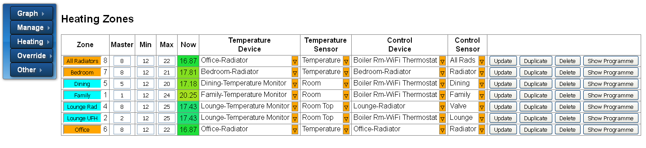
The fields and buttons that you are likely to use are:
Field | Description
Zone | The name (and number) of each zone. The field is coloured blue if there is no demand for heat or orange if there is. It is coloured red if an 'override' is active (whether or not it is calling for heat).
Master | The 'All Radiators' zone is designated a 'Master' zone as it will activate if any of its 'slave' zones are active (e.g. bedroom, office, Lounge Rad)
Now | The current temperature measurement of the zone. If the mouse cursor hovers over this field the current 'target' temperature is shown.
Show Programme | Click this button to show the programme for this zone

The remaining fields and buttons are used to reconfigure the system (so please avoid!).

Programme
Click the 'Show Programme' button to display and edit the programme for the selected zone.
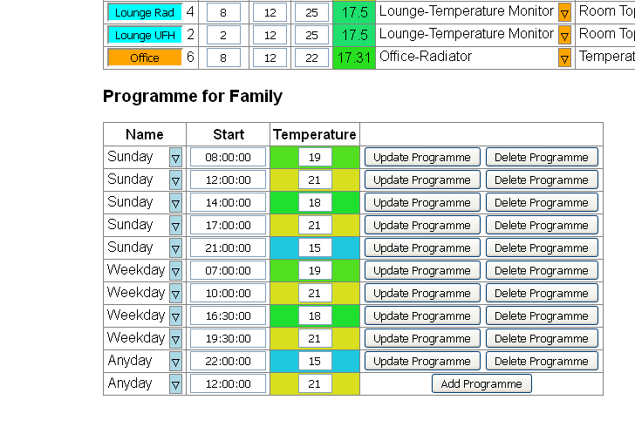

This controls the 'target' temperature for the zone according to the day of the week and time of day.
The day of the week can be:
- A specific day (Sunday – Saturday)
- Weekend or Weekday
- Any day
You change this by clicking on the blue triangle. A dialogue box will be displayed with the options.
The time of day can be changed either by typing in a new time (in the form hh:mm) or by selecting from the (long) drop-down box that is displayed when you click the field.
The temperature can be changed by typing in a new value. The background colour gives an indication of the temperature selected (within the Min/Max parameters shown on the Zones widow)

How it Works
The way the programme works is that it finds the set of temperatures whose day best matches the current day. With the above example if it is Sunday the first 5 will be used. If it is Monday-Friday the next 4 will be used. Other wise the last one will be used. (not really a good example for Saturday!)
Within that set of temperatures the first one whose time of day is >= to the current time is used.
If a temperature cannot be found the procedure is repeated for the previous day.
To save your changes click the Update button.

Overrides
Click the Heating/Overrides menu to show the display that allows you to temporarily override the temperature of one or more zones.
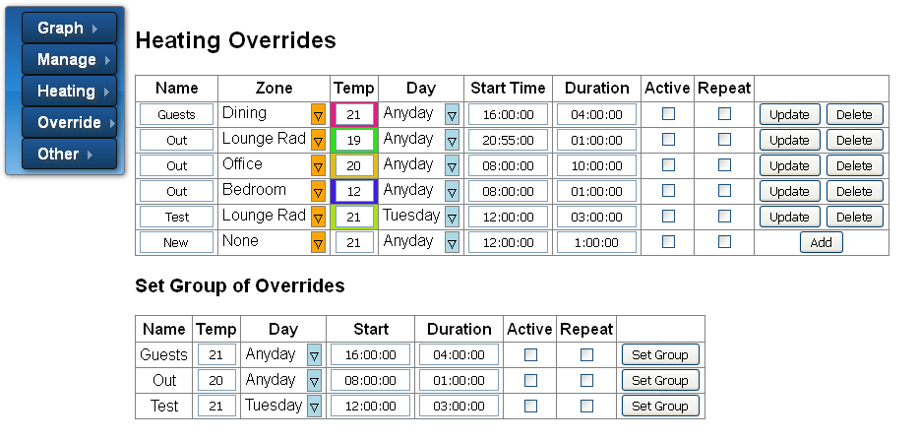
The fields and buttons that you are likely to use are:
Field | Description
Name | The name you give to the Override. Overrides with the same name can be activated all together.
Zone | The zone that will be overridden
Temp | The target temperature
Day | The day(s) the override will apply
Start Time & Duration | When the override will start and its duration. Note that if the duration is set to 00:00 it will mean 'all day'
Active/Repeat | The Active check box must be checked to actually apply the override. If 'Repeat' is not checked the 'Active' flag will be cleared at the end of the Override time.

Groups of Overrides
All the overrides with the same name can be set be clicking the appropriate 'Set Group' button.

